**Treatment Document: SS Great Eastern and Capt. Robert Halpin.**

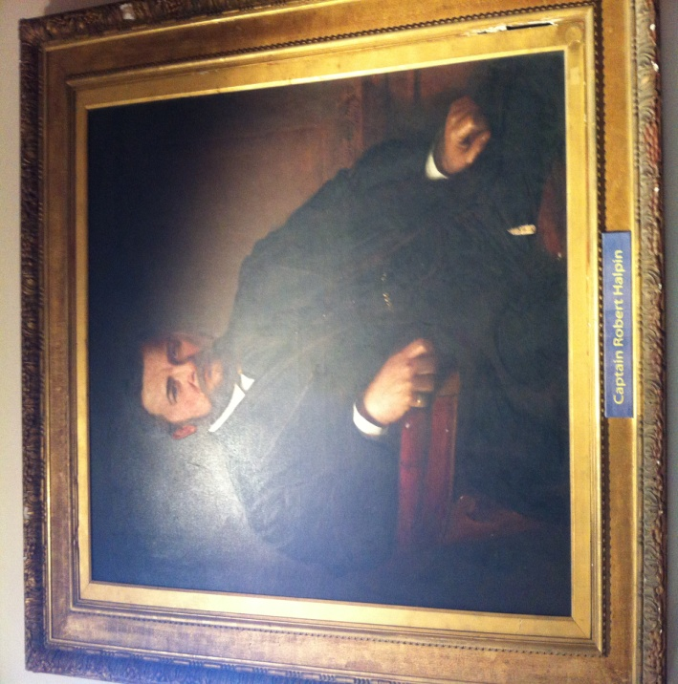

The areas we are studying closely are Halpins early life, his cable laying adventure and his life after.

This is the structure:

***Video #1***-Keypoints of Halpins life until the cable laying.

This video is accompanied by an audio script to enhance the learning experience.

After Video #1 the user will be prompted to play the game if the wish or to continue to Video #2.

***The Game***- This is to educate the user about Halpins difficulty in successfully laying the telegraphic cables. It is based on dropping the cable at the correct time in order to join two severed cables. It will display the SS Great Eastern and the user will have the option to grip on end of the cable. The user must then wait until the boat is over the cable so that when the grip is released the cable will float down to the right point and reconnect with the other half of the cable.

***Video #2-***Focusing on the significant event following the cable laying expedition for which he is probably most well known for.

Video #1 Script/Notes:

Robert Halpin was born in Wicklow town **(pictures of landmarks in Wicklow town)** in 1836.

He was the youngest of 13 children **(pics of family**

Young Halpin never took much of an interest in education because his passion was sailing and the sea **(pics of old sailing ships).** He left home at 10 to become a seafarer.

In 1858 Halpin Captained a steam-ship called the Propellor travelling from Ireland to America **(pic of the propeller if avail. and map of Ireland, America and the atlantic.)**

In 1859 while in control of a ship called ‘The Argo’ he shipwrecked off Newfoundland. Nobody was hurt however Halpin lost his masters for 9 months **(pics of the shipwreck)**

In 1865 he was appointed chief officer of ‘The SS Great Eastern’ the world’s biggest **ship (pics of G.E from different angles)**. The ships purpose was to lay telegraph cable across the Atlantic from Ireland to the U.S**.** The problem with the S.S. Great Eastern was that she was never filled to full capacity and was losing money. The vessel was sold in 1867 to a company that wanted to use the ship to bring American visitors to the Paris World Exhibition.

The SS Great Easternwas 693 feet in, 22,500 tons dead weight and had passenger accommodation for over 3000 passengers. Five times larger than any other ship then built, she had six masts named Monday, Tuesday, Wednesday etc..., five funnels, 6500 yards of sail, two 58 ft paddle wheels, a 24 ft screw (which remains the biggest ever built) and a coal carrying capacity of 15000 tons. **(pictures of telegraph cable/old fashioned telephones/detailed pics of the ship/from different angles).**

During Halpin’s first cable-laying process the cables broke just short of halfway across. They tried again the following year this time with success. Halpin somehow managed to navigate to the old telegraph cable which was in 2000 ft. of water and reattaching it. **(pictures of the ss g e while sailing and telegraph cables).**

**1.16**

1mins 15 sec long.

Video #2 Script/Notes:

Halpin retired from sea life and bought Tinakilly House in Wicklow. The name Tinakilly is derived from the townland of Tinakilly on which the house is built. It comes from the Gaelic; Ti=house: na=of the: Coille=wood. So the whole name in Irish means "House of the Wood". **(pics of Tinakilly House)**

The house was built by Halpin. The British Government gave him a blank cheque to build his new home in gratitude for his contribution to improving world communications and therefore world trade. He employed James Franklin Fuller, who was quite popular at the time, to design the house**. (pic of James+Tinakilly house).** The timber was imported from London and the firplace was imported from Italy. The cellar has enough room for 2000 bottles of wine.

The total cost of Halpin’s mansion was £40000 (**about £4m in todays value). (pic of Tinakilly)**

Halpin became involved in local politics and stood for parliament but was not successful. However Tinakilly house was a useful asset during his campaign for entertaining guests and learning political skills. One of Halpins earliest visitors was Alfred Lord Tennyson who is reputed to have read “In Memoriam” to a party of invited nuns.

There is an obelisk that stands in Fitzwilliam Square, Wicklow, that pays tribute to Robert Halpin and the work he did **(pic of fitwilliam square).**

Halpin died at the age of 58, having survived many years as a sailor, from blood poisoning after cutting his toe.

1 mins 13 secs long

Interactive game notes:

* The objective of the interactive game is to re-join the severed telegraph cables 2000 ft. under water.
* The ship will be moving at a slow pace across the screen. ‘PREPEARE TO DROP CABLE!’
* When the ship is sailing over the severed cable the user will be prompted to ‘DROP CABLE NOW!’
* There will be one of two outcomes; the user will drop the cable at the incorrect time and the cables will not re-join, or the user will drop the cable at the correct time and the cables will be reconnected.
  + If outcome 1 occurs what appears will be; ‘YOU MISSED THE CABLE. WOULD YOU LIKE TO TRY AGAIN?’
  + If outcome 2 occurs what will appear will be; ‘WELL DONE! YOU HAVE RECONNECTED THE CABLES! IRELAND CAN NOW COMMUNICATE WITH AMERICA!’
* After they complete this there will be a harder challenge.